PRACTICAL DBMS
NAME: K.VIJAYALAKSHMI
REG.NO:192511189
COURSE CODE: CSA0503
COURSE NAME: DATABASE MANAGEMENT SYSTEMS
EXPERIMENT NO:5 SELECT with various clause – WHERE, pattern matching
AIM:
To view the records from the tables using SELECT commands with WHERE Clause and Pattern matching.
DESCRIPTION:
The SELECT statement allows you to get the data from tables. A table consists of rows and columns like a
spreadsheet. Often, you want to see a subset rows, a subset of columns, or a combination of two. The result of the
SELECT statement is called a result set that is a list of rows, each consisting of the same number of columns.
SELECT:
SELECTcolumn_1, column_2, ...
FROMtable_1
[INNER | LEFT |RIGHT] JOIN table_2 ON conditions
WHEREconditions
GROUP BY column_1
HAVING group_conditions
ORDER BY column_1
LIMIT offset, length;
The SELECT statement consists of several clauses as explained in the following list:
➢ SELECT followed by a list of comma-separated columns or an asterisk (*)
to indicate that you want to return all columns.
➢ FROM specifies the table or view where you want to query the data.
➢ JOIN gets related data from other tables based on specific join conditions.
➢ WHERE clause filters row in the result set.
➢ GROUP BY clause groups a set of rows into groups and applies aggregate
functions on each group.
➢ HAVING clause filters group based on groups defined by GROUP BY clause.
➢ ORDER BY clause specifies a list of columns for sorting.
➢ LIMIT constrains the number of returned rows.
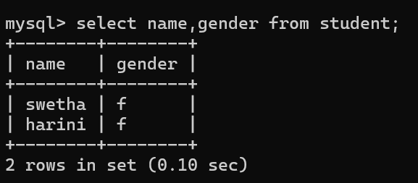
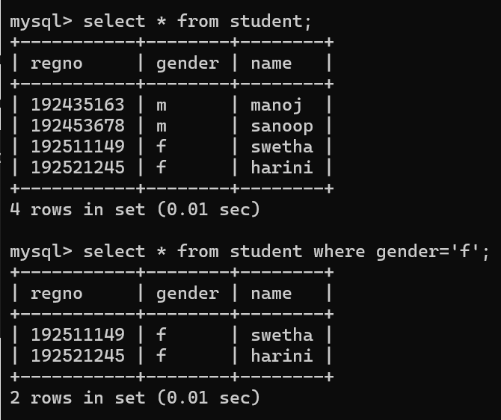
LIKE:
➢ The LIKE operator is commonly used to select data based on patterns. Using the LIKE operator in the right
way is essential to increase the query performance.
➢ The LIKE operator allows you to select data from a table based on a specified pattern. Therefore, the LIKE
operator is often used in the WHERE clause of the SELECT statement.
➢ MySQL provides two wildcard characters for using with the LIKE operator, the percentage % and
underscore _ .
➢ The percentage ( % ) wildcard allows you to match any string of zero or more characters.
➢ The underscore ( _ ) wildcard allows you to match any single character.

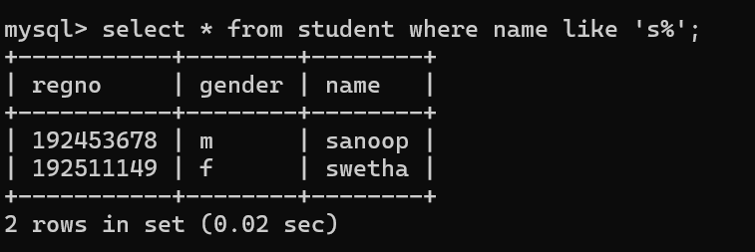
RESULT:
The records from the tables are displayed using SELECT commands with WHERE Clause and Pattern matching.

